**Exploring the potential area for a new movie theater**

Vu Minh Chien

January, 26 2020

1. Introduction

1.1 Background:

* The cinema company consider to increase their business and open more movie theater in 2020

1.2 Problem

The business stakeholders want to know Which location to build a new movie theater in Ho Chi Minh city, Viet Nam in order to attract as many customers as possible.

An understanding of existing location will help making the decision and after discussion with management team, strategic planning, data scientist team came out with the following hypothesis of the popular movie theater location

* Places surrounded by shopping street, hotel, entertainment spots.
* Near big road, does not locate in small roads.

My job is to confirm the above hypothesis and suggest more detailed of which locations to move forward.

1. Data

2.1 List of well-known movie theater

List of famous movie theater is taken from the website with the address, latitude and longitude information (Fig 1)

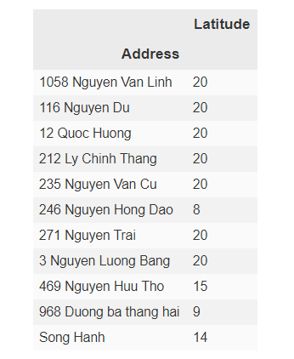

Figure 1. Dataset

2.2 Surrounding facility:

Surrounding facility information will be taken from Foursquare API data.

These two datasets will be joined for further analysis.

1. Methodology

Surrounding facilities will be chosen within 500 meters away from the target and limit to 20 places (Fig 2)

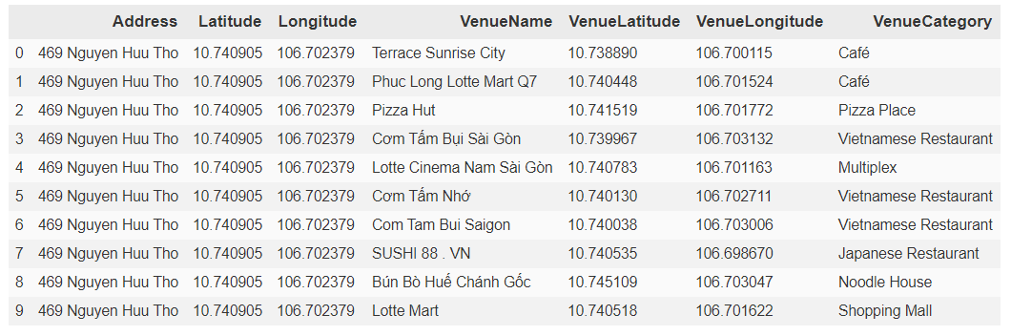

Figure 2. Joined dataset

This presents the other venues around the targeted theater as well as the Venues Category.

From the Venue category, we can understand which category should be together.

Then, I conduct Exploratory analysis to understand which type of venue category associates with each movie location as well as the frequency of appearance.

1. Result

Half of the theaters has 20 other facilities surrounded, while there are only 3 places have under 10 venue around (Fig.3).

There are 50 different categories within the list and the most appeared categories are Café (23), Vietnamese restaurant (12), Hotel (12), Coffee shop (10). (Fig.4). The Café shop is significant higher frequency compared to other venues.



Figure 3. List venue surrounding targeted movie

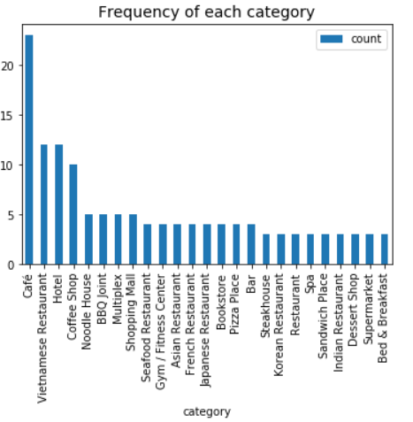

Figure 3. Frequency of venue category

1. Discussion

The current famous movie theaters are being surrounded by many venues such as restaurants, café/ coffee shop or hotel.

These movie theaters are considered as healthy performance locations so somehow, we can conclude that build a new theater within the ecosystem of the other restaurants and coffee shops might be a plus for the company’s performance.

1. Conclusion

In this study, I conducted an analysis on exploring the characteristic of current cinema location and make recommendation on the future potential new location for new movie theater.

I identified the surrounding venues, breaking by venue category, made a short exploratory analysis to answer the stakeholder question regarding the characteristics of healthy movie theater. The analysis focused on exploring the frequency of venue category while have not touched to the relationship of the venue category with the store’s performance. The revenue data will help quantify the relationship of healthy venues with its surrounding and it will contribute well to the further analysis.